**AFRICA POVERTY INSIGHT 1999-2018 TECHNICAL REPORT**

**DATA ANALYST: KIGBU ISTIFANUS**

**STUDENT ID: VEPH/20B/DA057**

**Outline**

• Introduction

• Data cleaning

• Pre-analysis

• Industry type

• Stakeholder

• Value of data to the company

• Story of Data

• Pre-analysis

• In-analysis

• Data visualization and Chart

• Observation and Recommendation

• Conclusion

• References and Appendices.

**Introduction**

The Africa Poverty Group works to understand and reduce poverty across the continent by collecting and analyzing key indicators such as the Multidimensional Poverty Index, Head Count Ratio, and Poverty Intensity. It monitors poverty trends over time, conducts research to identify causes and impacts, and provides policy recommendations to support effective poverty reduction. Through capacity building, knowledge sharing, and advocacy, the group promotes inclusive, sustainable development and works to improve access to education, healthcare, and economic opportunities for vulnerable communities.

.

**Data Cleaning**

* *A thorough data cleaning process was implemented to ensure the accuracy and reliability of the sales performance analysis. This process included multiple critical steps designed to enhance consistency, eliminate errors, and prepare the data for meaningful evaluation.*
* *Standardizing Inconsistent Data – Categorical data was harmonized to resolve labeling inconsistencies, creating a uniform format across the dataset. This step was essential for standardizing customer details, dealer information, and vehicle specifications within a cohesive framework.*
* Duplicate *Detection and Removal – A systematic review of the dataset was conducted to detect and remove duplicate entries. Eliminating redundant records helped maintain data integrity, reduce potential biases, and support a more precise analysis of sales patterns.*

**Pre-Analysis**

**Project Split:**

The following actions were undertaken during this session:  
*Data partitioning – The dataset was segmented into two groups, distinguishing independent variables (Category 1) from dependent variables (Category 2) to facilitate further analysis.*

**Category one: Independent values**

* Country
* Region
* Year

**Category two: Dependent values**

* Multidimensional Poverty Index (MPI)
* Head Count Ratio Year 1
* Head Count Ration Year 2
* Poverty Intensity year 1
* Poverty Intensity Year 2
* Total Population Year 1
* Total Population Year 2

**Industry Type**

United Nations

**Stakeholder:**

UN Agencies and Bodies e.g WHO, UNICEF, UNDP, UNHCR, FAO, UNESCO

**Story Of the Data**

* The data is telling a story about poverty occurrences in Africa, showing the numbers of people using in each country, people in each region, poverty intensity and total population per year.

**What Success Means**

Reducing the cases of poverty by promoting riches to citizenry

**Pre-analysis**

These are the initial trends that were observed.

**Potential Analysis**

* Top 10 incidence of poverty by MPI
* Generate poverty by Head counts
* population in relation to country
* Population in relation to region
* Poverty intensity by country
* poverty intensity by region

**Initial insight:**

Finetune the country with the highest poverty incidence and generate the encourage poverty alleviation programs.

* The country with the Highers multidimensional poverty index is recommended for preference attention to better the life of the citizen.
* The Year with the highest poverty by head count should be well researched and deduced the factor that led to that.
* Country with the highest population should be recommended for birth control so as to avoid poverty the following year.
* The most intensify Region with poverty should be encouraged on measures to adapt for better detailing.

.

**In-analysis Observations and inside**

Upon completing the analysis and generating the charts, the following insights were identified:

* The country with the Highers multidimensional poverty index is Ethiopia with 12.2 MPI .
* The Least Five category Nigeria falls the fifth with 7.2 multidimensional poverty index
* The Year with the highest poverty head count Is same Ethiopia with 1786.1 in the first year and 1683.6 in the second year.
* Country with the highest population is Ulttar Pradesh with 150228093.0 population

.

**In-analysis Insight**

* The country with the highers multidimensional poverty index is Ethopia with 12.2 MPI therefore I recommend the stakeholders to pay more attention to poverty alleviation programs to boost the financial status of its people and also focus on Job creation in Ethiopia.
* Nigeria also falls under the five countries with 7.2 MPI therefore more emphasis should be considered in wealth creation.
* Ethiopia with the Highest poverty headcount is also recommended for close attention in terms of budget creation so as to pay close attention in boosting the economy of its country.
* Ultra-Pradesh is the country with the highest population of 150,228,093 but did not fall under the poorest country therefore I recommended for birth control so as to avoid overpopulation in the country and prevent poverty attraction in the feature.

**Data Visualization and Charts**

**Dashboard**

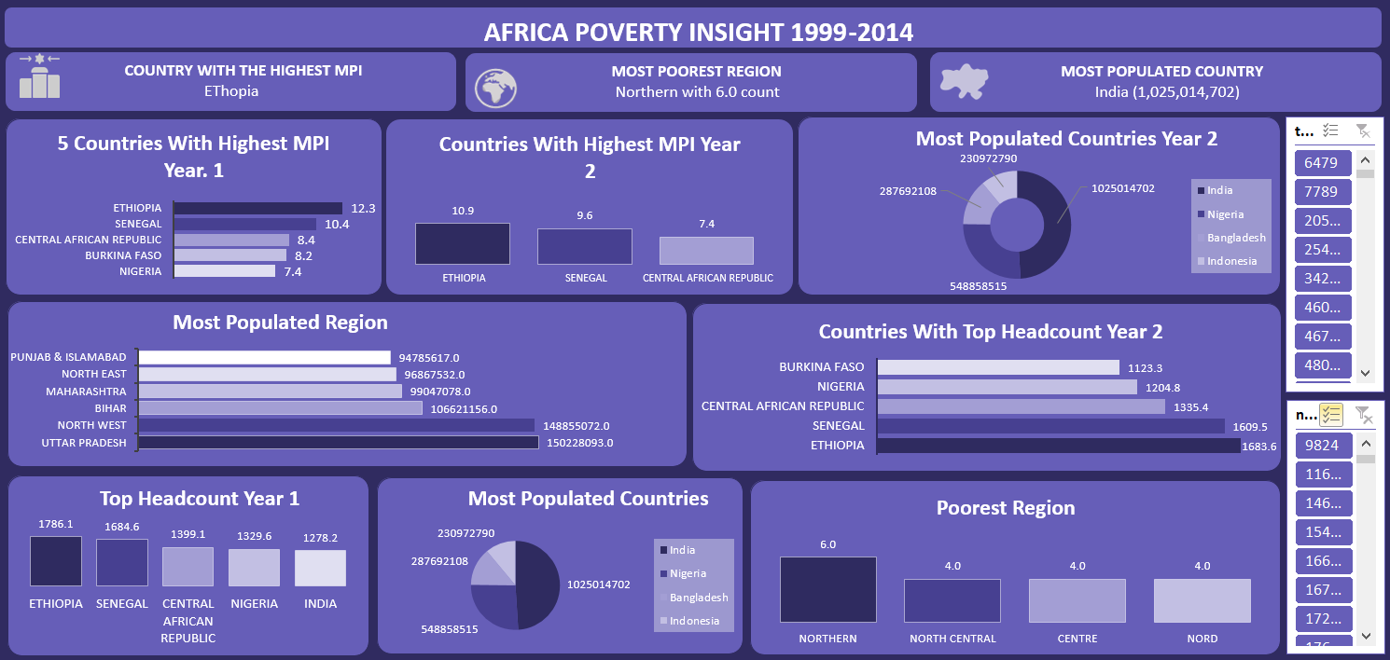

**Observations**

* The country with the Highers multidimensional poverty index is Ethiopia with 12.2 MPI .
* The Least Five category Nigeria falls the fifth with 7.2 multidimensional poverty index
* The Year with the highest poverty head count Is same Ethiopia with 1786.1 in the first year and 1683.6 in the second year.
* Country with the highest population is Ulttar Pradesh with 150228093.0 population

**Recommendation**

* The country with the higher multidimensional poverty index is Ethiopia with 12.2 MPI therefore I recommend the stakeholders to pay more attention to poverty alleviation programs to boost the financial status of its people and also focus on Job creation in Ethiopia.
* Nigeria also falls under the five countries with 7.2 MPI therefore more emphasis should be considered in wealth creation.
* Ethiopia with the Highest poverty headcount is also recommended for close attention in terms of budget creation so as to pay close attention in boosting the economy of its country.
* Ulttar Pradesh is the country with the highest population of 150,228,093 but did not fall under the poorest country therefore I recommended for birth control so as to avoid overpopulation in the country and prevent poverty attraction in the feature.

**Conclusion:**

In summary, Ethiopia ranks as the country with the highest Multidimensional Poverty Index (MPI) at 12.2 and also records the highest poverty headcount in both years analyzed, indicating a severe level of poverty. Nigeria, while not the highest, still falls among the top five with a significant MPI of 7.2, signaling a need for urgent socio-economic interventions. Interestingly, Uttar Pradesh, despite having the highest population at over 150 million, does not rank among the poorest regions, which highlights the complex relationship between population size and poverty levels.

These findings underscore the importance of targeted poverty alleviation strategies. Ethiopia, in particular, requires focused attention from stakeholders in terms of job creation, financial empowerment, and budget allocation. Nigeria also warrants policies that support wealth creation and economic development. Furthermore, while Uttar Pradesh is not currently among the poorest, proactive population control measures are advisable to prevent future poverty-related challenges.

**Reference**

UNDP: Multidimensional Poverty Index dataset. Kaggle. <https://www.kaggle.com/datasets/> undp/multidimensional-poverty-index